Contents

1. Symptoms 2

2. Running SQL Tuning Advisor 27

3. Implementing the SQL Profile 29

4. Implementing the index recommendations 29

# Symptoms

Below complex TPW query is taking 12 minutes the first time because of the high volume of data. Once the data is loaded into the buffer cache it only takes about 2 minutes.

WITH vw_attributes

AS (SELECT object_id,

object_type,

object_class,

object_name,

object_tsmodified,

REF28_TYPE_TRAVAUX,

NVL (

ref211_processus,

CASE

WHEN ref62_flux IN ('AU', 'HS', 'PA')

THEN

ref62_flux

WHEN ref62_flux IS NULL

OR ref62_flux IN ('DH', 'DI')

THEN

CASE

WHEN ref55_entite_ra = 'Public'

OR ref55_entite_ra = 'Admin/Contractor'

THEN

'PU'

WHEN ref55_entite_ra = 'Private'

THEN

'PR'

WHEN ref55_entite_ra = 'Autor'

OR ref55_entite_ra = 'Prorogation(VP)'

THEN

'AU'

WHEN ref55_entite_ra = 'Patrimonium'

THEN

'PA'

END

WHEN ref62_flux = 'RE'

THEN

CASE

WHEN ref12_etat_rech IN ('NC', 'CC')

THEN

ref12_etat_rech

WHEN ref12_etat_rech = 'CS'

THEN

CASE

WHEN ref55_entite_ra = 'Public'

OR ref55_entite_ra =

'Admin/Contractor'

THEN

'CP'

WHEN ref55_entite_ra = 'Private'

THEN

'CT'

ELSE

'PC'

END

ELSE

'PC'

END

END)

generalized_process

FROM attributes)

SELECT h.container,

d.object_id,

d.object_type,

d.object_class,

d.object_name,

d.object_tsmodified

FROM attributes d, hierarchy h

WHERE d.object_type = 2 AND d.object_id = h.contained

AND d.object_id NOT IN

('00119GPRD114151',

'00129GPRD115588',

'03254GPRD525994',

'03267GPRD532545',

'03321GPRD561819',

'04019GPRD598657',

'04021GPRD599724',

'04036GPRD610830',

'04049GPRD620920',

'04139GPRD680472',

'04139GPRD680483',

'04139GPRD680485',

'04140GPRD680664',

'04197GPRD718604',

'04202GPRD720799',

'04209GPRD723585',

'04236GPRD738452',

'04238GPRD740601',

'04240GPRD742585',

'04240GPRD742588',

'04259GPRD754867',

'04299GPRD783110',

'04331GPRD804761',

'04351GPRD819083',

'05013GPRD835858',

'05014GPRD836012',

'05061GPRD870753',

'05061GPRD870763',

'05068GPRD877089',

'05096GPRD896932',

'05096GPRD897072',

'05138GPRD926703',

'05143GPRD929956',

'05143GPRD929960',

'05143GPRD929963',

'05143GPRD929968',

'05143GPRD929974',

'05143GPRD929984',

'05143GPRD929992',

'05143GPRD929998',

'05143GPRD929999',

'05143GPRD930000',

'05143GPRD930008',

'05143GPRD930009',

'05143GPRD930010',

'05143GPRD930011',

'05143GPRD930012',

'05143GPRD930013',

'05143GPRD930027',

'05143GPRD930028',

'05143GPRD930030',

'05147GPRD934657',

'05147GPRD934669',

'05147GPRD934742',

'05147GPRD934747',

'05172GPRD953847',

'05186GPRD965157',

'05206GPRD978084',

'05215GPRD983783',

'05215GPRD983784',

'05217GPRD986220',

'05231GPRD998031',

'05235GPRD999620',

'05235GPRD999733',

'05235GPRD999753',

'05248GPRD008902',

'05248GPRD008952',

'05249GPRD010685',

'05265GPRD023909',

'05266GPRD025105',

'05272GPRD030561',

'05283GPRD039761',

'05283GPRD039762',

'05283GPRD039764',

'05283GPRD039765',

'05283GPRD039768',

'05283GPRD039771',

'05283GPRD039772',

'05283GPRD039778',

'05283GPRD039780',

'05283GPRD039783',

'05290GPRD045311',

'05290GPRD046367',

'05297GPRD053142',

'05297GPRD053212',

'05298GPRD054888',

'05298GPRD054889',

'05304GPRD057946',

'05308GPRD060720',

'05309GPRD061691',

'05309GPRD061699',

'05312GPRD063867',

'05318GPRD068869',

'05318GPRD068917',

'05318GPRD068933',

'05349GPRD093717',

'05354GPRD098046',

'05354GPRD098284',

'06016GPRD118124',

'06019GPRD123308',

'06037GPRD138251',

'06037GPRD138266',

'06037GPRD138290',

'06037GPRD138297',

'06037GPRD138300',

'06039GPRD141082',

'06044GPRD147484',

'06077GPRD185321',

'06077GPRD185329',

'06084GPRD192845',

'06085GPRD192846',

'06100GPRD208820',

'06123GPRD230398',

'06123GPRD231333',

'06123GPRD231334',

'06124GPRD231390',

'06143GPRD251519',

'06151GPRD258042',

'06178GPRD283453',

'06178GPRD283473',

'06178GPRD283479',

'06186GPRD292805',

'06191GPRD296748',

'06191GPRD297279',

'06194GPRD302031',

'06196GPRD302883',

'06196GPRD302888',

'06196GPRD302917',

'06196GPRD302941',

'06197GPRD302947',

'06197GPRD302948',

'06198GPRD303269',

'06198GPRD303314',

'06198GPRD303732',

'06199GPRD304894',

'06234GPRD329021',

'06257GPRD353976',

'06262GPRD358300',

'06272GPRD369553',

'06272GPRD369556',

'06272GPRD369558',

'06275GPRD370262',

'06298GPRD397204',

'06327GPRD426010',

'06327GPRD426011',

'07051GPRD515470',

'07059GPRD524052',

'07123GPRD594584',

'07135GPRD608105',

'07136GPRD609153',

'07151GPRD623855',

'07151GPRD623858',

'07169GPRD644543',

'07339GPRD817118',

'08002GPRD838783',

'08085GPRD924959',

'08098GPRD937251',

'08100GPRD939795',

'08101GPRD942056',

'08106GPRD946813',

'10131GPRD724161',

'10177GPRD768290',

'10177GPRD768310',

'10357GPRD958937',

'11033GPRD996186',

'11144GPRD115063',

'11252GPRD215463',

'11277GPRD238636',

'11279GPRD241738',

'11279GPRD241776',

'11279GPRD241888',

'11355GPRD311524',

'11363GPRD317064',

'12083GPRD000201',

'12097GPRD012776',

'12110GPRD024496',

'12292GPRD206781',

'14048GPRD638265',

'14085GPRD673379',

'16282GPRD187572',

'16306GPRD189107',

'00259GPRD139819',

'03167GPRD477936',

'03199GPRD499640',

'03217GPRD506299',

'03217GPRD506335',

'03293GPRD548489',

'04019GPRD598656',

'04021GPRD599723',

'04021GPRD599729',

'04022GPRD601154',

'04033GPRD607865',

'04056GPRD625388',

'04068GPRD634190',

'04075GPRD638219',

'04079GPRD642005',

'04113GPRD663531',

'04139GPRD680481',

'04146GPRD683520',

'04153GPRD687671',

'04155GPRD689303',

'04156GPRD691299',

'04156GPRD691380',

'04201GPRD720068',

'04209GPRD723611',

'04210GPRD723870',

'04240GPRD742587',

'04240GPRD742596',

'04240GPRD742597',

'04288GPRD775619',

'04293GPRD779216',

'04320GPRD796097',

'04342GPRD811046',

'04344GPRD814530',

'04344GPRD814537',

'05004GPRD829247',

'05096GPRD896938',

'05096GPRD897153',

'05108GPRD906740',

'05118GPRD915112',

'05124GPRD917548',

'05143GPRD929958',

'05143GPRD929962',

'05143GPRD929965',

'05143GPRD929966',

'05143GPRD929973',

'05143GPRD929977',

'05143GPRD929978',

'05143GPRD929979',

'05143GPRD929980',

'05143GPRD929983',

'05143GPRD929986',

'05143GPRD929987',

'05143GPRD929988',

'05143GPRD929989',

'05143GPRD929990',

'05143GPRD929991',

'05143GPRD929994',

'05143GPRD929996',

'05143GPRD929997',

'05143GPRD930001',

'05143GPRD930005',

'05143GPRD930006',

'05143GPRD930007',

'05143GPRD930020',

'05143GPRD930021',

'05143GPRD930022',

'05143GPRD930023',

'05143GPRD930025',

'05143GPRD930026',

'05143GPRD930033',

'05143GPRD930034',

'05143GPRD930035',

'05145GPRD932126',

'05235GPRD999764',

'05235GPRD999790',

'05248GPRD009166',

'05283GPRD039775',

'05283GPRD039776',

'05283GPRD039777',

'05283GPRD039779',

'05283GPRD039781',

'05283GPRD039784',

'05283GPRD039787',

'05283GPRD039788',

'05283GPRD039789',

'05283GPRD039790',

'05290GPRD046122',

'05297GPRD053352',

'05298GPRD054892',

'05299GPRD056039',

'05299GPRD056115',

'05304GPRD057951',

'05309GPRD061698',

'05309GPRD061703',

'05314GPRD066430',

'05314GPRD066697',

'05326GPRD075738',

'05328GPRD078169',

'05336GPRD084439',

'05336GPRD084519',

'05336GPRD084534',

'05342GPRD088366',

'06003GPRD106779',

'06003GPRD106782',

'06003GPRD106785',

'06003GPRD106794',

'06018GPRD121860',

'06019GPRD122263',

'06044GPRD147665',

'06064GPRD168333',

'06064GPRD168344',

'06064GPRD168345',

'06077GPRD185333',

'06086GPRD194384',

'06086GPRD194388',

'06086GPRD194389',

'06086GPRD194390',

'06103GPRD213454',

'06103GPRD213459',

'06114GPRD222990',

'06114GPRD222991',

'06114GPRD222992',

'06123GPRD230633',

'06123GPRD230707',

'06124GPRD231452',

'06129GPRD237415',

'06143GPRD251521',

'06151GPRD258044',

'06178GPRD283455',

'06178GPRD283458',

'06178GPRD283459',

'06178GPRD283460',

'06178GPRD283462',

'06178GPRD283463',

'06178GPRD283464',

'06178GPRD283465',

'06178GPRD283466',

'06178GPRD283467',

'06178GPRD283468',

'06178GPRD283469',

'06178GPRD283470',

'06178GPRD283471',

'06178GPRD283472',

'06178GPRD283475',

'06178GPRD283476',

'06178GPRD283477',

'06178GPRD283478',

'06178GPRD283481',

'06191GPRD297000',

'06196GPRD302885',

'06196GPRD302886',

'06196GPRD302887',

'06196GPRD302890',

'06196GPRD302891',

'06196GPRD302892',

'06196GPRD302901',

'06196GPRD302905',

'06196GPRD302915',

'06196GPRD302943',

'06197GPRD302944',

'06197GPRD302945',

'06197GPRD302950',

'06197GPRD302952',

'06198GPRD303742',

'06201GPRD305967',

'06201GPRD305984',

'06206GPRD308791',

'06208GPRD309751',

'06208GPRD309842',

'06230GPRD326746',

'06230GPRD326841',

'06272GPRD369551',

'06272GPRD369555',

'06272GPRD369561',

'06272GPRD369562',

'06292GPRD391544',

'06299GPRD397772',

'06299GPRD397965',

'06299GPRD397989',

'06299GPRD398028',

'06306GPRD403887',

'06318GPRD415201',

'06319GPRD415431',

'06319GPRD415500',

'06321GPRD419031',

'06321GPRD419034',

'06342GPRD440141',

'07037GPRD498165',

'07142GPRD613782',

'07151GPRD623857',

'07151GPRD623860',

'07164GPRD638934',

'07187GPRD666336',

'07241GPRD718738',

'07263GPRD741766',

'07351GPRD829370',

'08029GPRD867130',

'08211GPRD050473',

'09054GPRD272999',

'09118GPRD345009',

'09125GPRD351975',

'09160GPRD386845',

'09205GPRD433274',

'09266GPRD498128',

'09322GPRD552786',

'09324GPRD555702',

'09328GPRD558948',

'10175GPRD767344',

'10177GPRD768316',

'10300GPRD897307',

'11066GPRD032803',

'11277GPRD239241',

'11279GPRD240867',

'11279GPRD241879',

'11321GPRD279783',

'12130GPRD040778',

'12146GPRD058230',

'12297GPRD210679',

'13004GPRD275819',

'13164GPRD422617',

'13333GPRD575245',

'14163GPRD734080',

'14163GPRD734500',

'14231GPRD780497',

'15058GPRD913247',

'15061GPRD914297',

'15118GPRD953271',

'16186GPRD181960',

'11328GPRD286397',

'11332GPRD288280',

'13193GPRD450995')

AND d.object_class NOT IN ('P1_PD')

AND NOT (d.object_class = 'COUROUT'

AND (d.ref211_processus = 'FC' OR d.object_name LIKE 'R-L%'))

AND NOT (d.object_class = 'P1_RS' AND d.man520_id_ged_fc IS NULL)

AND h.container IN

(SELECT DISTINCT f.object_id

FROM hierarchy him,

hierarchy hom,

attributes im,

vw_attributes om,

attributes f

WHERE f.object_id = him.container

AND f.object_id = hom.container

AND f.object_type = 3

AND f.object_class = 'DOSSIER_FC'

AND im.object_type = 2

AND im.object_id = him.contained

AND im.object_class IN

('COURIN', 'FLX_IN_GENERAL', 'NOTEINT', 'P1_RS')

AND NOT (im.object_class = 'COURIN'

AND SUBSTR (im.object_id, 1, 2) IN

('14', '15', '16')

AND MOD (NVL (im.ref16_enre_entrant, 0),

1000000) >= 500000)

AND om.object_type = 2

AND om.object_id = hom.contained

AND om.object_class = 'COUROUT'

AND (om.generalized_process IN

('CC',

'CP',

'CR',

'CT',

'DF',

'DI',

'NC',

'PC',

'RS')

OR (om.generalized_process = 'PU'

AND (om.REF28_TYPE_TRAVAUX IS NULL

OR om.REF28_TYPE_TRAVAUX IN

('Public18',

'Public20',

'Public206',

'Public30',

'Public31',

'Public43',

'RS1')))

OR (om.generalized_process IS NULL

AND om.REF28_TYPE_TRAVAUX IN

('Prive10',

'Prive17',

'Prive18',

'Prive20',

'Prive208',

'Prive21',

'Prive210',

'Prive59',

'Prive6',

'Prive66',

'Prive67',

'Prive72',

'Prive8',

'Prive9',

'Public1',

'Public10',

'Public11',

'Public12',

'Public13',

'Public18',

'Public2',

'Public20',

'Public204',

'Public206',

'Public21',

'Public22',

'Public23',

'Public24',

'Public25',

'Public250',

'Public26',

'Public29',

'Public3',

'Public30',

'Public31',

'Public32',

'Public34',

'Public35',

'Public4',

'Public43',

'Public45',

'Public5',

'Public6',

'Public8',

'Public9',

'RS1'))

OR (om.generalized_process IS NULL

AND om.REF28_TYPE_TRAVAUX IS NULL

AND NOT EXISTS

(SELECT id

FROM linksgeddz

WHERE idztype = 4

AND iobjectid =

om.object_id))

OR im.object_id IN

(SELECT object_id

FROM eventstable

WHERE action_type = 'save_and_send'

AND username = 'system'

AND workset = 'AU_ANSWER')

OR om.object_id IN

('99216GPRD008934',

'99216GPRD009084',

'99223GPRD010160',

'99242GPRD018702',

'99242GPRD018882',

'99259GPRD035326',

'99284GPRD051624',

'99287GPRD056768',

'99288GPRD057157',

'99330GPRD063681',

'00059GPRD101936',

'00138GPRD117950',

'00150GPRD119862',

'00161GPRD121678',

'00172GPRD123072',

'00187GPRD125897',

'00200GPRD130571',

'00206GPRD131096',

'00209GPRD131479',

'00216GPRD132229',

'00242GPRD136712',

'00287GPRD145754',

'00291GPRD146433',

'00291GPRD146467',

'00300GPRD148608',

'00305GPRD149562',

'00343GPRD161474',

'00343GPRD161490',

'00343GPRD161501',

'00362GPRD165961',

'01017GPRD170396',

'01024GPRD171549',

'01029GPRD172654',

'01052GPRD178768',

'01067GPRD184650',

'01073GPRD186332',

'01110GPRD195388',

'01135GPRD204044',

'01136GPRD204514',

'01138GPRD204943',

'01163GPRD210595',

'01163GPRD210604',

'01177GPRD214730',

'01190GPRD218604',

'01197GPRD220063',

'01222GPRD225851',

'01232GPRD227561',

'01241GPRD230861',

'01243GPRD232088',

'01243GPRD232090',

'01261GPRD238925',

'01270GPRD241273',

'01270GPRD241353',

'01271GPRD242441',

'01285GPRD245986',

'01288GPRD247139',

'01288GPRD247213',

'01288GPRD247236',

'01288GPRD247239',

'01288GPRD247244',

'01288GPRD247276',

'01291GPRD248452',

'01296GPRD249523',

'01337GPRD259935')

OR im.object_id IN

('01068RPRD221658',

'01072RPRD222876',

'01221RPRD270321',

'01249RPRD280857',

'03017RPRD761975',

'06262RPRD477261',

'06342GPRD440895',

'07029GPRD489153',

'07124GPRD595616',

'07218RPRD601922',

'07288RPRD628556',

'08015GPRD851554',

'08129GPRD970626',

'09358GPRD589799',

'11139RPRD041664'))

AND im.object_id NOT IN

('00119GPRD114151',

'00129GPRD115588',

'03254GPRD525994',

'03267GPRD532545',

'03321GPRD561819',

'04019GPRD598657',

'04021GPRD599724',

'04036GPRD610830',

'04049GPRD620920',

'04139GPRD680472',

'04139GPRD680483',

'04139GPRD680485',

'04140GPRD680664',

'04197GPRD718604',

'04202GPRD720799',

'04209GPRD723585',

'04236GPRD738452',

'04238GPRD740601',

'04240GPRD742585',

'04240GPRD742588',

'04259GPRD754867',

'04299GPRD783110',

'04331GPRD804761',

'04351GPRD819083',

'05013GPRD835858',

'05014GPRD836012',

'05061GPRD870753',

'05061GPRD870763',

'05068GPRD877089',

'05096GPRD896932',

'05096GPRD897072',

'05138GPRD926703',

'05143GPRD929956',

'05143GPRD929960',

'05143GPRD929963',

'05143GPRD929968',

'05143GPRD929974',

'05143GPRD929984',

'05143GPRD929992',

'05143GPRD929998',

'05143GPRD929999',

'05143GPRD930000',

'05143GPRD930008',

'05143GPRD930009',

'05143GPRD930010',

'05143GPRD930011',

'05143GPRD930012',

'05143GPRD930013',

'05143GPRD930027',

'05143GPRD930028',

'05143GPRD930030',

'05147GPRD934657',

'05147GPRD934669',

'05147GPRD934742',

'05147GPRD934747',

'05172GPRD953847',

'05186GPRD965157',

'05206GPRD978084',

'05215GPRD983783',

'05215GPRD983784',

'05217GPRD986220',

'05231GPRD998031',

'05235GPRD999620',

'05235GPRD999733',

'05235GPRD999753',

'05248GPRD008902',

'05248GPRD008952',

'05249GPRD010685',

'05265GPRD023909',

'05266GPRD025105',

'05272GPRD030561',

'05283GPRD039761',

'05283GPRD039762',

'05283GPRD039764',

'05283GPRD039765',

'05283GPRD039768',

'05283GPRD039771',

'05283GPRD039772',

'05283GPRD039778',

'05283GPRD039780',

'05283GPRD039783',

'05290GPRD045311',

'05290GPRD046367',

'05297GPRD053142',

'05297GPRD053212',

'05298GPRD054888',

'05298GPRD054889',

'05304GPRD057946',

'05308GPRD060720',

'05309GPRD061691',

'05309GPRD061699',

'05312GPRD063867',

'05318GPRD068869',

'05318GPRD068917',

'05318GPRD068933',

'05349GPRD093717',

'05354GPRD098046',

'05354GPRD098284',

'06016GPRD118124',

'06019GPRD123308',

'06037GPRD138251',

'06037GPRD138266',

'06037GPRD138290',

'06037GPRD138297',

'06037GPRD138300',

'06039GPRD141082',

'06044GPRD147484',

'06077GPRD185321',

'06077GPRD185329',

'06084GPRD192845',

'06085GPRD192846',

'06100GPRD208820',

'06123GPRD230398',

'06123GPRD231333',

'06123GPRD231334',

'06124GPRD231390',

'06143GPRD251519',

'06151GPRD258042',

'06178GPRD283453',

'06178GPRD283473',

'06178GPRD283479',

'06186GPRD292805',

'06191GPRD296748',

'06191GPRD297279',

'06194GPRD302031',

'06196GPRD302883',

'06196GPRD302888',

'06196GPRD302917',

'06196GPRD302941',

'06197GPRD302947',

'06197GPRD302948',

'06198GPRD303269',

'06198GPRD303314',

'06198GPRD303732',

'06199GPRD304894',

'06234GPRD329021',

'06257GPRD353976',

'06262GPRD358300',

'06272GPRD369553',

'06272GPRD369556',

'06272GPRD369558',

'06275GPRD370262',

'06298GPRD397204',

'06327GPRD426010',

'06327GPRD426011',

'07051GPRD515470',

'07059GPRD524052',

'07123GPRD594584',

'07135GPRD608105',

'07136GPRD609153',

'07151GPRD623855',

'07151GPRD623858',

'07169GPRD644543',

'07339GPRD817118',

'08002GPRD838783',

'08085GPRD924959',

'08098GPRD937251',

'08100GPRD939795',

'08101GPRD942056',

'08106GPRD946813',

'10131GPRD724161',

'10177GPRD768290',

'10177GPRD768310',

'10357GPRD958937',

'11033GPRD996186',

'11144GPRD115063',

'11252GPRD215463',

'11277GPRD238636',

'11279GPRD241738',

'11279GPRD241776',

'11279GPRD241888',

'11355GPRD311524',

'11363GPRD317064',

'12083GPRD000201',

'12097GPRD012776',

'12110GPRD024496',

'12292GPRD206781',

'14048GPRD638265',

'14085GPRD673379',

'16282GPRD187572',

'16306GPRD189107')

AND om.object_id NOT IN

('00259GPRD139819',

'03167GPRD477936',

'03199GPRD499640',

'03217GPRD506299',

'03217GPRD506335',

'03293GPRD548489',

'04019GPRD598656',

'04021GPRD599723',

'04021GPRD599729',

'04022GPRD601154',

'04033GPRD607865',

'04056GPRD625388',

'04068GPRD634190',

'04075GPRD638219',

'04079GPRD642005',

'04113GPRD663531',

'04139GPRD680481',

'04146GPRD683520',

'04153GPRD687671',

'04155GPRD689303',

'04156GPRD691299',

'04156GPRD691380',

'04201GPRD720068',

'04209GPRD723611',

'04210GPRD723870',

'04240GPRD742587',

'04240GPRD742596',

'04240GPRD742597',

'04288GPRD775619',

'04293GPRD779216',

'04320GPRD796097',

'04342GPRD811046',

'04344GPRD814530',

'04344GPRD814537',

'05004GPRD829247',

'05096GPRD896938',

'05096GPRD897153',

'05108GPRD906740',

'05118GPRD915112',

'05124GPRD917548',

'05143GPRD929958',

'05143GPRD929962',

'05143GPRD929965',

'05143GPRD929966',

'05143GPRD929973',

'05143GPRD929977',

'05143GPRD929978',

'05143GPRD929979',

'05143GPRD929980',

'05143GPRD929983',

'05143GPRD929986',

'05143GPRD929987',

'05143GPRD929988',

'05143GPRD929989',

'05143GPRD929990',

'05143GPRD929991',

'05143GPRD929994',

'05143GPRD929996',

'05143GPRD929997',

'05143GPRD930001',

'05143GPRD930005',

'05143GPRD930006',

'05143GPRD930007',

'05143GPRD930020',

'05143GPRD930021',

'05143GPRD930022',

'05143GPRD930023',

'05143GPRD930025',

'05143GPRD930026',

'05143GPRD930033',

'05143GPRD930034',

'05143GPRD930035',

'05145GPRD932126',

'05235GPRD999764',

'05235GPRD999790',

'05248GPRD009166',

'05283GPRD039775',

'05283GPRD039776',

'05283GPRD039777',

'05283GPRD039779',

'05283GPRD039781',

'05283GPRD039784',

'05283GPRD039787',

'05283GPRD039788',

'05283GPRD039789',

'05283GPRD039790',

'05290GPRD046122',

'05297GPRD053352',

'05298GPRD054892',

'05299GPRD056039',

'05299GPRD056115',

'05304GPRD057951',

'05309GPRD061698',

'05309GPRD061703',

'05314GPRD066430',

'05314GPRD066697',

'05326GPRD075738',

'05328GPRD078169',

'05336GPRD084439',

'05336GPRD084519',

'05336GPRD084534',

'05342GPRD088366',

'06003GPRD106779',

'06003GPRD106782',

'06003GPRD106785',

'06003GPRD106794',

'06018GPRD121860',

'06019GPRD122263',

'06044GPRD147665',

'06064GPRD168333',

'06064GPRD168344',

'06064GPRD168345',

'06077GPRD185333',

'06086GPRD194384',

'06086GPRD194388',

'06086GPRD194389',

'06086GPRD194390',

'06103GPRD213454',

'06103GPRD213459',

'06114GPRD222990',

'06114GPRD222991',

'06114GPRD222992',

'06123GPRD230633',

'06123GPRD230707',

'06124GPRD231452',

'06129GPRD237415',

'06143GPRD251521',

'06151GPRD258044',

'06178GPRD283455',

'06178GPRD283458',

'06178GPRD283459',

'06178GPRD283460',

'06178GPRD283462',

'06178GPRD283463',

'06178GPRD283464',

'06178GPRD283465',

'06178GPRD283466',

'06178GPRD283467',

'06178GPRD283468',

'06178GPRD283469',

'06178GPRD283470',

'06178GPRD283471',

'06178GPRD283472',

'06178GPRD283475',

'06178GPRD283476',

'06178GPRD283477',

'06178GPRD283478',

'06178GPRD283481',

'06191GPRD297000',

'06196GPRD302885',

'06196GPRD302886',

'06196GPRD302887',

'06196GPRD302890',

'06196GPRD302891',

'06196GPRD302892',

'06196GPRD302901',

'06196GPRD302905',

'06196GPRD302915',

'06196GPRD302943',

'06197GPRD302944',

'06197GPRD302945',

'06197GPRD302950',

'06197GPRD302952',

'06198GPRD303742',

'06201GPRD305967',

'06201GPRD305984',

'06206GPRD308791',

'06208GPRD309751',

'06208GPRD309842',

'06230GPRD326746',

'06230GPRD326841',

'06272GPRD369551',

'06272GPRD369555',

'06272GPRD369561',

'06272GPRD369562',

'06292GPRD391544',

'06299GPRD397772',

'06299GPRD397965',

'06299GPRD397989',

'06299GPRD398028',

'06306GPRD403887',

'06318GPRD415201',

'06319GPRD415431',

'06319GPRD415500',

'06321GPRD419031',

'06321GPRD419034',

'06342GPRD440141',

'07037GPRD498165',

'07142GPRD613782',

'07151GPRD623857',

'07151GPRD623860',

'07164GPRD638934',

'07187GPRD666336',

'07241GPRD718738',

'07263GPRD741766',

'07351GPRD829370',

'08029GPRD867130',

'08211GPRD050473',

'09054GPRD272999',

'09118GPRD345009',

'09125GPRD351975',

'09160GPRD386845',

'09205GPRD433274',

'09266GPRD498128',

'09322GPRD552786',

'09324GPRD555702',

'09328GPRD558948',

'10175GPRD767344',

'10177GPRD768316',

'10300GPRD897307',

'11066GPRD032803',

'11277GPRD239241',

'11279GPRD240867',

'11279GPRD241879',

'11321GPRD279783',

'12130GPRD040778',

'12146GPRD058230',

'12297GPRD210679',

'13004GPRD275819',

'13164GPRD422617',

'13333GPRD575245',

'14163GPRD734080',

'14163GPRD734500',

'14231GPRD780497',

'15058GPRD913247',

'15061GPRD914297',

'15118GPRD953271',

'16186GPRD181960'))

# Running SQL Tuning Advisor

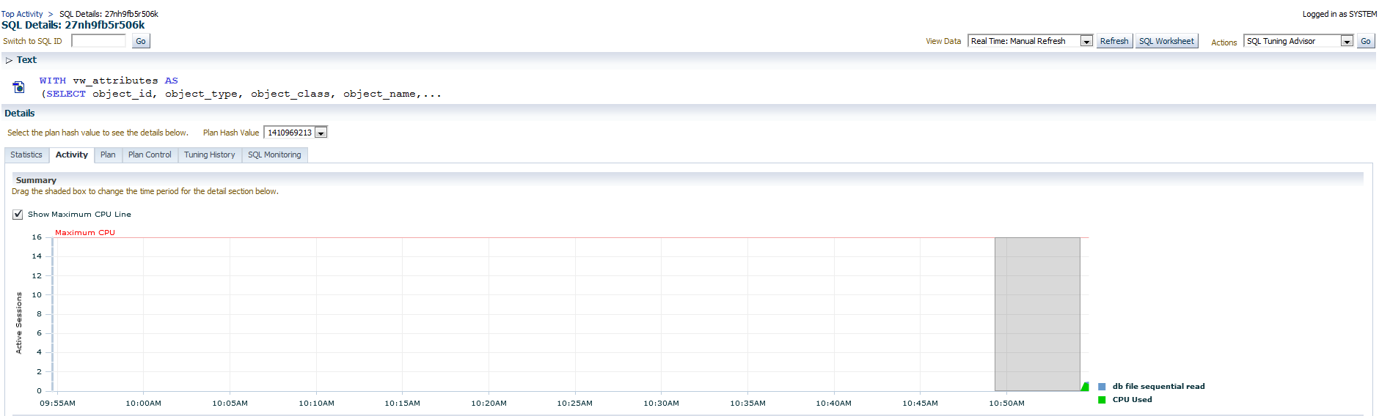

**Select SQL Tuning Advisor in the dropdown list and click GO**

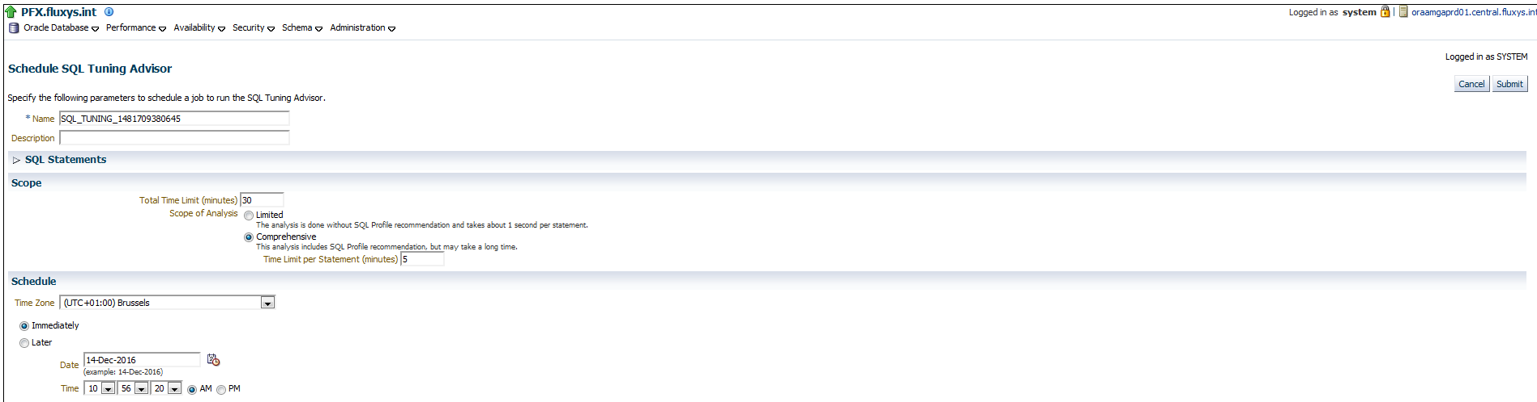

Click on Submit

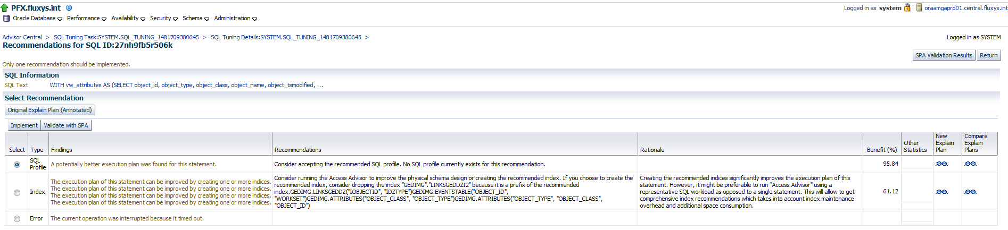

So now we see that the SQL Tuning Advisor has found a better execution plan by implementing an SQL Profile. The benefit in this case could be 95%.

# Implementing the SQL Profile

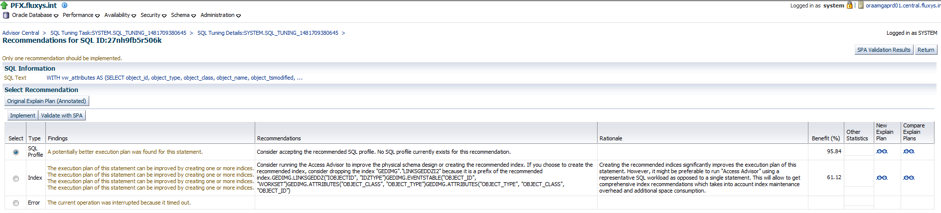

Click on Implement

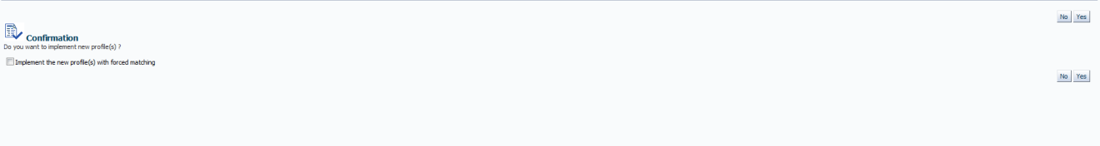

Click Yes

So from now on as long as the sql text does not change, this query should always use the same plan.

The SQL Profile did not actually help and still runs for 12 minutes.

# Implementing the index recommendations

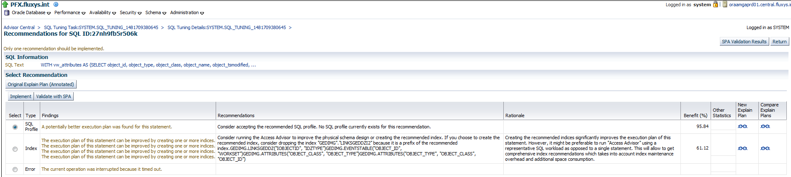

We will now create the recommended indexes

Drop the index "GEDIMG"."LINKSGEDDZI2" because it is a prefix of one of the recommended indexes.

Create following indexes

GEDIMG.LINKSGEDDZ("IOBJECTID", "IDZTYPE")

GEDIMG.EVENTSTABLE("OBJECT_ID", "WORKSET")

GEDIMG.ATTRIBUTES("OBJECT_CLASS", "OBJECT_TYPE")

GEDIMG.ATTRIBUTES("OBJECT_TYPE", "OBJECT_CLASS", "OBJECT_ID")

By implementing these indexes, the query runs now in 8 minutes.